Admin Section: In the src folder we have
- Auth
- Components
- Context
- Data
- App.jsx
- Main.jsx
2. Components : we 9 folder and in which is we define components to render ui and reuse.
- AnnouncementPage :
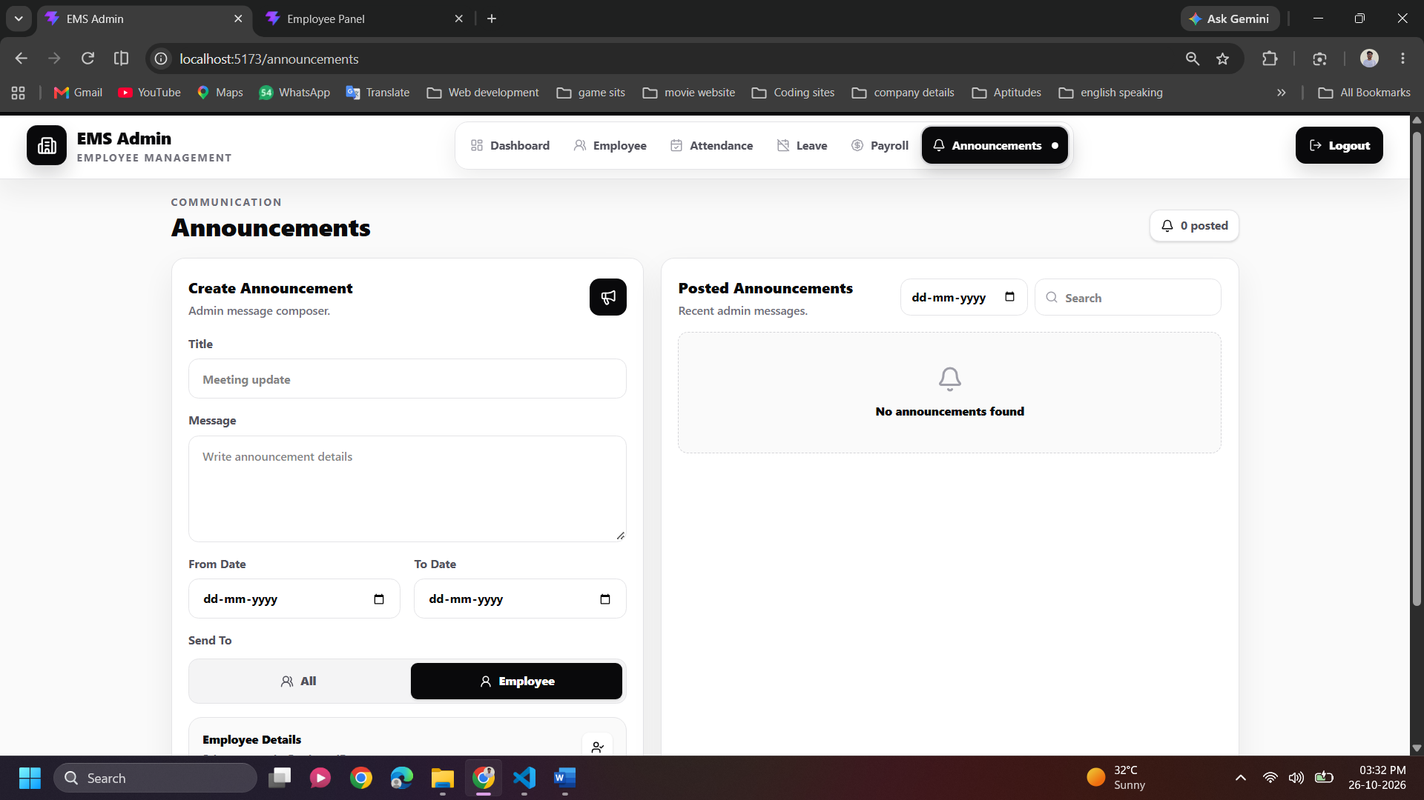

AnnouncementPage Component: This component allows the admin to create, send, search, filter, view, and delete announcements for all employees or a specific employee.
It uses React hooks and shared context to manage state and fetch data from the backend API, with date validation, loading indicators, and toast notifications.

- DashboardPage : - this is admin dashboard that show employees information of total employees , Totol salary expense and Total Announcements and fetching data through DataContext.
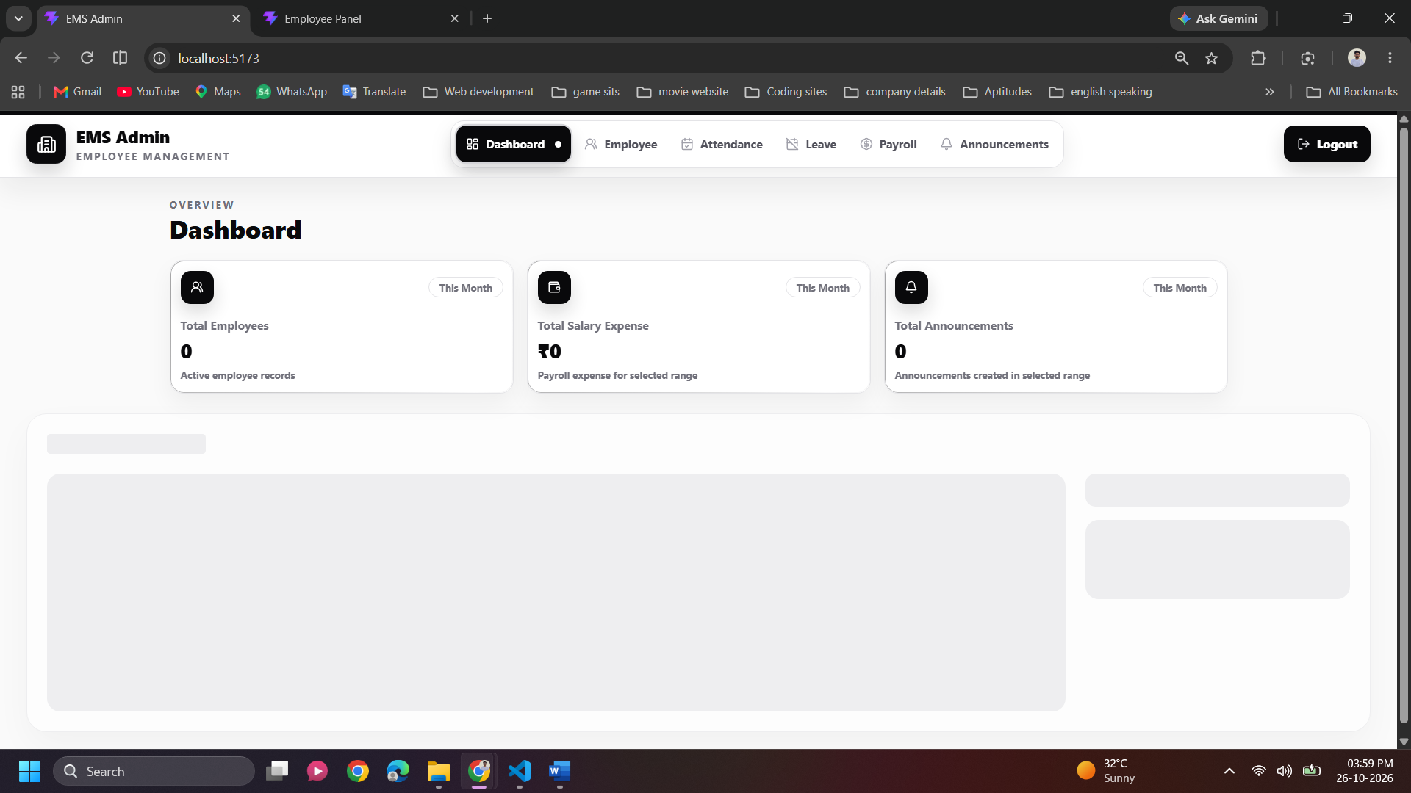
- ChartsPage : This component displays interactive dashboard charts for employee count, salary, and announcements with daily, weekly, monthly, and yearly filters.
It fetches chart data from the backend API, calculates statistics such as total and peak values, and renders wave or bar charts based on the selected metric and time period.

- LeavesPage :- in this admin can see employee leave request by employee name , id, date, and status and It fetches leave data from the backend, allows the admin to approve or reject request
- LoginPage :- This component provides the admin login page, validates email and password inputs and authenticates the admin, and redirects to the dashboard after successful login.
- When admin type correct email and passward and admin can hide and show thire password and after click on login then handleSubmit() check validations
- Navbar :- this components displays the admin navigation bar , admin can navigate on different components
- When admin Click Dashboard / Employee / Attendance / Leave / Payroll / Announcements
- EmployeePage :-
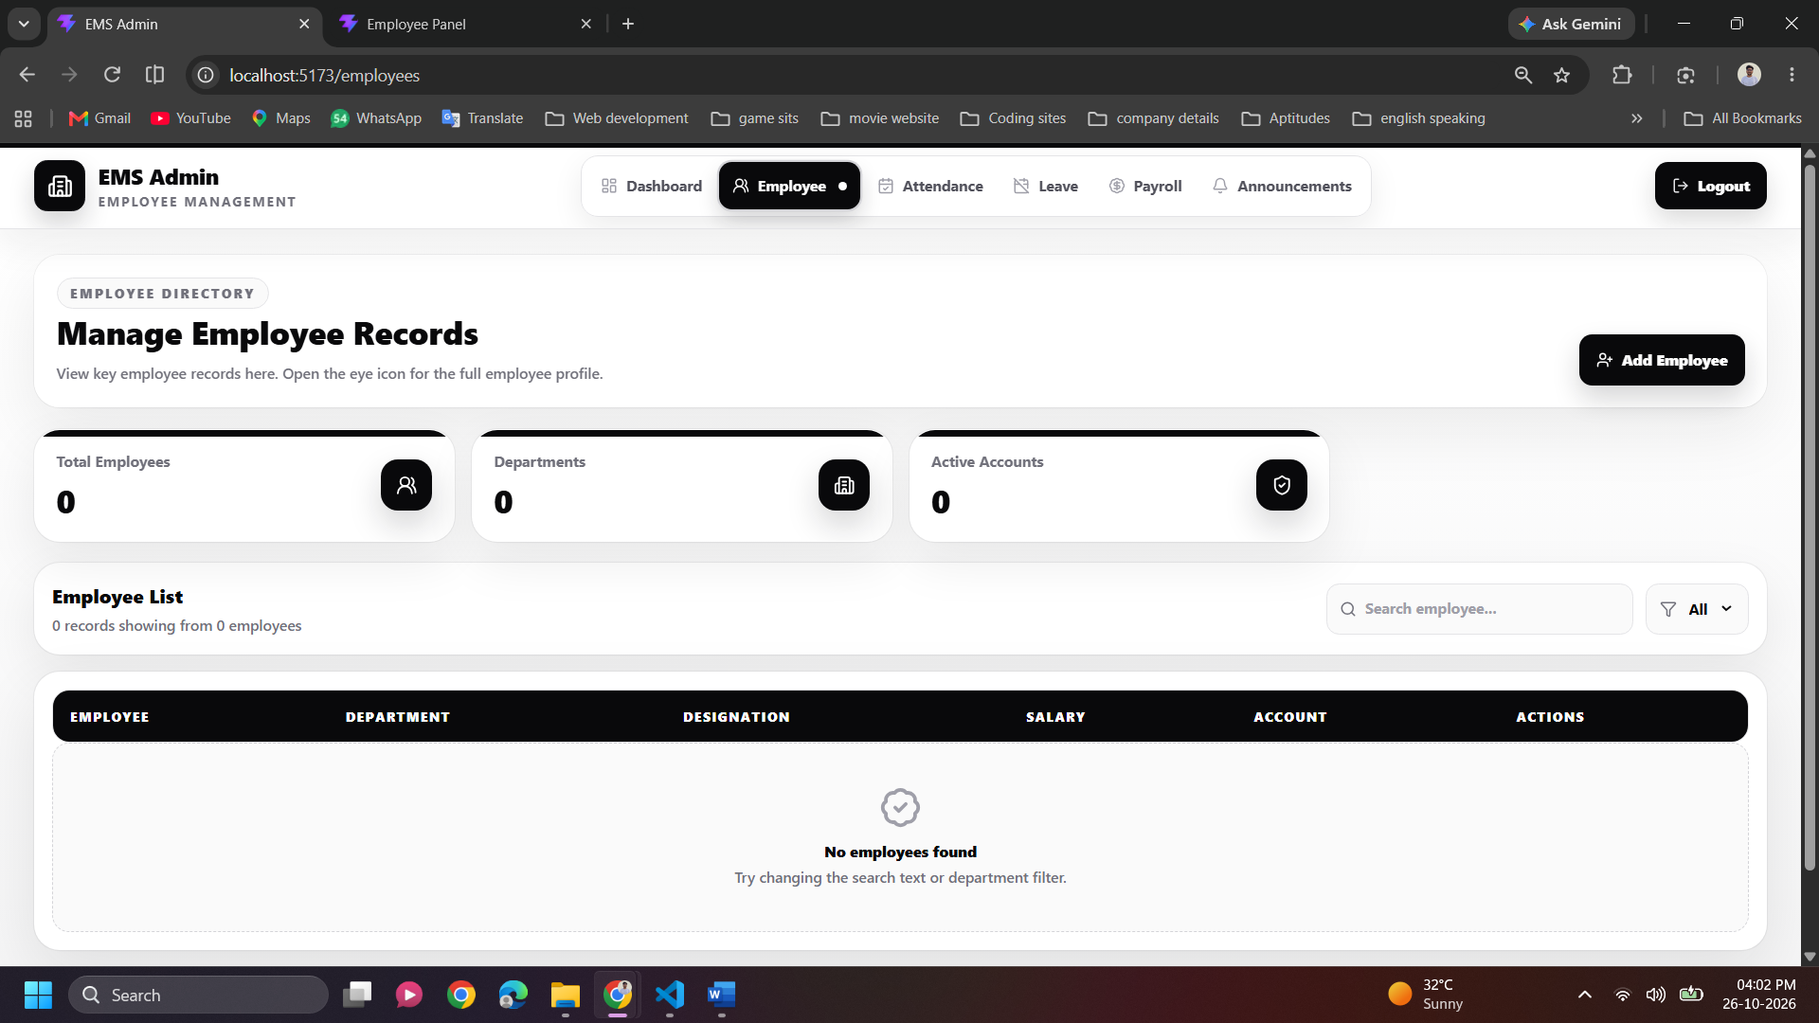

- PayRollPage
- AttendancePage

3. Context folder have DataContext.jsx :
This create createContext that is central shared data store for employees, payrolls and announcement

Backend section : -
- Brevo api :- it is transactional email that are automated, non-promotional messages triggered by user actions such as account creation, order confirmations, and password resets.
- Salary :- When admin add employee and employee details then
In the Salary section admin can write e chartered instead of number

- Full Name :- Name should be string not a number
- Email and work Email not same
- Designations: I can write only string
- Bank name should be string

- Apply React hook form in ems project

